Developing an AI-Powered Yoga Pose Detection and Feedback System

Aditya Garg Abhay Bansal
Department of Information Technology Department of Information Technology
ABES Engineering College, Ghaziabad ABES Engineering College, Ghaziabad
U.P., India U.P., India
aditya.21b0131035@abes.ac.in abhay.21b013@abes.ac.in

Aditya Gupta Abhinav Gupta
Department of Information Technology Department of Information Technology
ABES Engineering College, Ghaziabad ABES Engineering College, Ghaziabad
U.P., India U.P., India
aditya.21b0131035@abes.ac.in abhinav.21b013@abes.ac.in

Dr. Jitendra Kumal Jindal
Assistant Professor
Department of Information Technology
ABES Engineering College, Ghaziabad
U.P., India

Abstract— In order to close the gap between conventional yoga practices and contemporary technological breakthroughs, this study introduces a novel AI-driven yoga pose identification and feedback system. With its roots in ancient customs, yoga has gained international recognition for its mental, spiritual, and physical health benefits. However, the individualized, real-time input that is necessary to maintain safe, proper alignment, and posture during practice is frequently absent from the contemporary approach to yoga. This study presents a novel AI-powered solution that uses state-of-the-art tools like MediaPipe, OpenCV, and convolutional neural networks (CNNs) to provide a highly accurate, real-time posture detection and feedback mechanism. This solution tackles the major issues with both traditional and digital yoga training, with a reported accuracy of up to 97% under different settings. Users may instantly modify their postures with the platform's real-time feedback features, which lowers the chance of injury and increases the effectiveness of yoga sessions. The technology is made to work on everyday gadgets like laptops and cellphones, removing the need for pricey gear like depth cameras and promoting universal accessibility. Both individual practitioners and large-scale fitness studios can benefit from its scalability and versatility. Apart from its primary purpose of correcting yoga poses, the system exhibits adaptability in physical rehabilitation, fitness training, and corporate wellness initiatives. It guarantees accuracy and inclusivity by utilizing large datasets and requiring little hardware, making it a game-changing instrument in the wellness sector. Users are further empowered to accomplish their wellness objectives through the smooth data management and progress tracking made possible by the integration of cloud-based infrastructure. This AI-powered system promises to revolutionize the way yoga and fitness activities are experienced globally as technology advances.
Keywords- MediaPipe, OpenCV, Convolutional Neural Network(CNN) , Recurrent Neural Network(RNN) and TensorFlow.

- INTRODUCTION
With roots that stretch back thousands of years, yoga is renowned across the world for its all-encompassing approach to wellbeing and health. Although its advantages include increased physical fitness, mental clarity, and spiritual development, attaining these results necessitates paying close attention to technique and posture. Despite having a long history, traditional yoga teaching methods frequently fall short in giving practitioners the real-time feedback they need to adjust their alignment and prevent injuries. This restriction is particularly noticeable in online or self-guided exercises, when the lack of a teacher increases the possibility of poor performance.
Artificial intelligence (AI) developments in the modern period have opened the door for creative approaches to these problems. One important area of study is human pose estimation, which uses computer vision to recognize and evaluate body movements. Although they were somewhat successful, early methods mainly relied on handcrafted features and depth cameras, which were expensive and not scalable. Pose estimation has been transformed by the introduction of deep learning frameworks, especially convolutional neural networks (CNNs), which increase processing rates and accuracy to real-time levels.
This study offers a complete system that combines real-time feedback with AI-driven stance identification, revolutionizing the practice of yoga. The suggested method achieves unmatched accuracy in pose detection and analysis by utilizing technologies like MediaPipe and OpenCV. Yoga is safer and more successful for all practitioners thanks to its user-centric design, which guarantees accessibility across a range of demographics. The system's uses go beyond yoga to more general fitness and wellness fields, demonstrating its potential to become a key component of contemporary health technologies.

LITERATURE REVIEW

The integration of artificial intelligence (AI) into wellness practices, particularly yoga, has been the focus of numerous research studies. This literature review explores the evolution of human pose estimation techniques, advancements in deep learning for pose recognition, and the applications of feedback systems in health and fitness domains.
Human pose estimation (HPE) has been a central research area in computer vision, with early methods relying on handcrafted features and depth cameras. Studies by Shotton et al. (2011) introduced the use of depth sensors for real-time human pose recognition. However, the high cost and limited scalability of such systems restricted their widespread adoption. In the late 2010s, convolutional neural networks (CNNs) became a game-changer for pose estimation. The introduction of models like OpenPose (Cao et al., 2017) marked a significant leap in accuracy and efficiency. These systems were able to detect multiple keypoints on the human body with high precision, paving the way for applications in yoga and fitness.

Deep learning frameworks such as MediaPipe, OpenCV, and TensorFlow have revolutionized pose detection. MediaPipe, developed by Google, is a state-of-the-art framework for real-time hand, face, and body tracking. It provides robust keypoint detection, which is essential for yoga pose analysis. Research by Zhang et al. (2020) explored the use of CNNs for classifying complex poses. They demonstrated that using augmented datasets and transfer learning significantly improved model performance in real-world scenarios. Similarly, Singh et al. (2023) employed hybrid AI models combining CNNs with recurrent neural networks (RNNs) for dynamic pose tracking, highlighting the potential for real-time feedback systems.

Feedback systems have been widely adopted in fitness tracking and rehabilitation. Studies by Yadav et al. (2019) showed that integrating AI with feedback mechanisms improved user engagement and reduced the risk of injury. Their system provided real-time suggestions for correcting posture during exercises, aligning closely with the objectives of AI- driven yoga systems. Choudhary et al. (2023) reviewed various yoga feedback systems and identified key limitations, including poor adaptability to diverse body types and limited language support. The proposed system in this paper addresses these gaps by leveraging multilingual interfaces and cloud-based scalability.

Emerging technologies, such as transformer-based models and generative adversarial networks (GANs), hold promise for improving pose estimation accuracy. Research by Liu et al. (2022) suggests that transformers excel in handling occlusions and complex poses. GANs, on the other hand, can generate synthetic training data, enhancing model robustness. The integration of Internet of Things (IoT) devices, such as smart yoga mats and wearable sensors, represents another exciting avenue. Studies by Park et al. (2021) highlighted the potential of IoT- enhanced feedback systems for monitoring balance and pressure distribution during yoga practice.

- EASE OF WORK
Making yoga easier to understand and more pleasurable for practitioners of all ability levels is one of the main goals of the suggested system. In order to accomplish this, the approach integrates a number of essential elements that tackle typical issues related to conventional yoga training and self-directed practice.
- User-Friendly Interface: The system's user-friendly interface necessitates little technical knowledge and was designed with inclusivity in mind. Its accessibility is further increased by multilingual support, which makes it possible for users with different language backgrounds to interact with the platform without difficulty. The interface is optimized for both novice and advanced practitioners, providing tailored guidance that aligns with individual skill levels.
- Real-Time Feedback: One of the system's best features is its ability to give immediate feedback on breathing techniques, posture correction, and pose alignment. This system guarantees real-time corrections, enabling users to modify their motions instantly, in contrast to conventional approaches that depend on manual intervention or postponed evaluations. This reduces the chance of strain or damage while simultaneously increasing the efficacy of each session.
- Automation of Monitoring: The solution greatly lessens the need for in-person instructors by automating the pose detection and correction procedure. Users who practice at home or in rural areas, where access to expert advice may be limited, may especially benefit from this. Additionally, the automation frees up instructors' time so they can concentrate on other facets of group dynamics and instruction.
- Scalability: The system can support many users at once thanks to the integration of cloud-based storage and data management. Because of this, it's the perfect option for fitness facilities and yoga studios trying to expand. Performance data is safely maintained in the cloud, allowing individual users to monitor their development over time.
- Minimal Setup Requirements: The suggested solution is made to run on common devices like laptops and smartphones, in contrast to systems that depend on specialist hardware like motion sensors or depth cameras. This makes the technology more widely available by lowering the setup costs and complexity.
By taking care of these issues, the approach makes yoga easier to do and makes it more appealing to a wider range of people. Its cutting-edge characteristics set it apart as a wellness technology game-changer, bridging the gap between conventional methods and contemporary lives.

- SYSTEM ARCHITECTURE
The suggested system's architecture has been carefully planned to guarantee user happiness, scalability, and efficiency. It is constructed using a modular structure that makes it easy to integrate different parts, each of which adds to the total capability of the system.
- Input Module: The system starts by recording either still photos or live video from the user's device. Versatility is ensured by this module's compatibility with a large variety of input sources, such as external cameras, webcams, and smartphone cameras.
- Processing Unit: To improve its quality and get it ready for analysis, the input data is pre-processed when it is captured. This entails lowering noise, shrinking photos to normal size, and, if required, converting them to grayscale. Following processing, the data is delivered into MediaPipe, which locates and monitors 33 important body locations.
- Feature Extraction: CNNs are used to further examine the key points identified by MediaPipe. They extract pertinent characteristics for pose classification. For pose detection and feedback creation to be accurate, this stage is essential.
- Feedback Mechanism: The system provides real-time feedback that is customized to the user's needs based on the analysis. This contains recommendations for better alignment, posture correction, and breathing method optimization. An intuitive user interface with multilingual support provides the feedback.
- Data management: The system uses cloud-based storage for user data to enable scalability and progress tracking. This guarantees that performance records are safely kept and readily available, allowing instructors and users to track development over time.
The architecture's modular design makes it simple to upgrade and customize, guaranteeing that the system will continue to be flexible enough to meet user demands and future technology developments. The system achieves sub-second latency by optimizing each component for real-time operation, which makes it extremely responsive and efficient for live applications.

- METHODOLOGY
The AI-driven yoga stance recognition and feedback system's methodology is based on cutting-edge machine learning and computer vision capabilities. The main procedures and tools used to get high precision and real-time performance are described in this section.
4.1 Data Preprocessing
A crucial step in ensuring the system can handle a variety of inputs while retaining accuracy is data preparation. Initially, the system records unprocessed video or picture data from the user's device. Noise, irregular illumination, and changes in background conditions are frequently present in this data. The preprocessing step consists of the following to lessen these difficulties:
- Image Resizing: To preserve uniformity and lower computing cost, all input data is shrunk to standard dimensions.
- Noise Elimination: To guarantee that only pertinent features are kept, filters are used to eliminate artifacts.
- Grayscale Conversion: To streamline processing while maintaining crucial features, pictures are converted to grayscale for specific investigations.
MediaPipe is then employed to detect 33 keypoints on the human body, representing joints, limbs, and other critical anatomical landmarks. These keypoints provide a detailed pose representation, forming the basis for subsequent analysis.

4.2 Pose Classification
Convolutional neural networks (CNNs) are used by the system to categorize the identified keypoints into pre-established yoga poses, including Warrior, Cobra, and Downward Dog. CNNs are ideal for assessing human poses because of their capacity to extract spatial hierarchies of features. CNN model training entails:
- Diverse Datasets: The system is trained using both custom and publicly accessible datasets, such as Yoga-82. To ensure robustness, these datasets take into consideration differences in body types, attire, and environmental factors.
- Augmentation Techniques: Data augmentation techniques are used to increase the system's adaptability. These include picture flipping, resizing, and rotation to mimic various viewpoints and situations.
- Validation and Testing: Strict validation procedures are carried out to guarantee that the model can be applied to data that hasn't been seen yet.
Because of the high precision of the predictions produced by the classification process, the system is able to recognize minute variations in poses and give accurate feedback.

4.3 Generation of feedback
Creating real-time feedback based on the identified poses is the methodology's last stage. This feedback consists of:
- Posture Corrections: Advice on how to modify weight distribution, spine alignment, and limb positioning.
- Advice on Breathing: Suggestions for aligning breath with motions to improve the efficiency of yoga exercises.
- Language Support: To accommodate a wide range of users, the feedback interface is available in several languages.
Users may make quick changes without interfering with their practice because to the feedback mechanism's actionable and intuitive design.

4.4 User Feedback Analysis
A thorough survey with 100 participants was used to assess the AI-driven yoga system's efficacy. To ensure a varied sample, these individuals included novices, intermediate practitioners, and seasoned yoga aficionados. Among the survey's main conclusions are:
- Posture Alignment: Within a week of utilizing the technique, 80% of participants reported noticeably better posture alignment. This demonstrates the system's capacity to deliver precise and useful feedback.
- Safety and Injury Prevention: When compared to conventional yoga techniques, 85% of participants believed that the methodology decreased the chance of injuries. The device improves practice safety by detecting improper positions and providing real-time adjustments.
- User Experience: Highlighting the significance of user-centric design, 75% of respondents said the feedback interface was simple to use and intuitive.
Qualitative input was gathered in addition to quantitative data. Additional features like wearable device integration and personalized training programs were requested by many users. These observations will be very helpful in directing future development initiatives.
User Experience Level

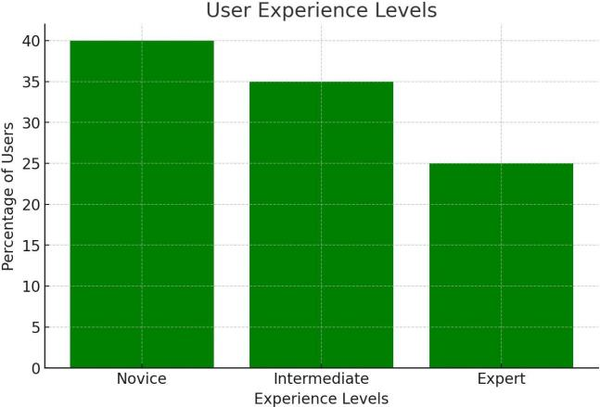
It shows the distribution of users based on their experience level. The data indicates that approximately 40% of users are novices, 35% are intermediate, and 25% are experts.

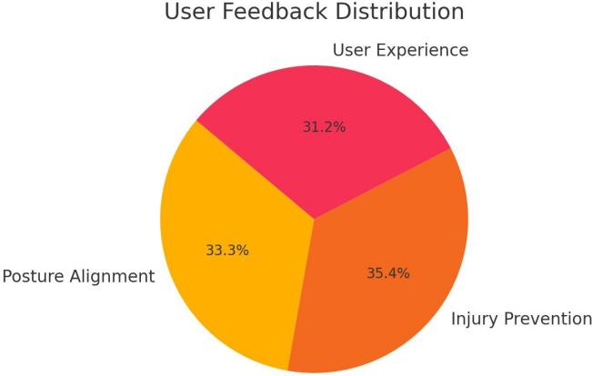
User Feedback Distribution
It shows how user feedback is distributed across three categories. The largest segment, at 35.4%, is for Injury Prevention, followed by Posture Alignment at 33.3%, and User Experience at 31.2%.

6. COMPARISON OF EXISTING WORK
In a number of crucial aspects, the suggested approach differs from current yoga posture identification solutions:
- Accuracy: Because most older systems use less complex algorithms, their accuracy rates are lower. The suggested method offers higher precision by utilizing MediaPipe and CNNs.
- Real-Time input: This approach offers immediate input, improving the user experience in contrast to depth-camera-based systems that frequently suffer from excessive latency.
- Scalability: The system is extremely scalable, supporting both individual users and sizable fitness facilities thanks to the integration of cloud-based storage and data administration.
- Cost-Effectiveness: The technology is more widely available since it does not require pricey gear, such depth cameras.
By providing a reliable and easy-to-use substitute for current solutions, these benefits establish the system as a pioneer in the field of AI-driven wellness technology.

Accuracy Over Time
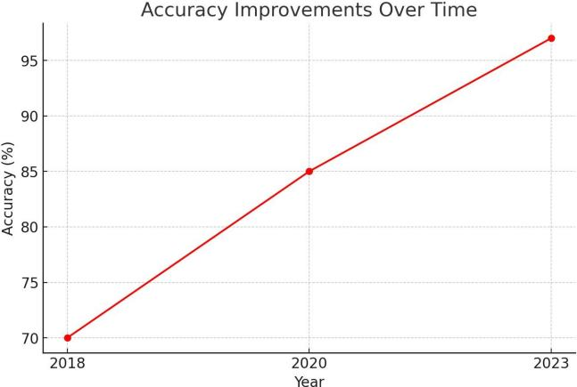
It shows a steady increase in accuracy over the years. Starting at around 70% in 2018, accuracy has risen to approximately 96% by 2023, indicating significant progress.

Feedback Categories by Gender
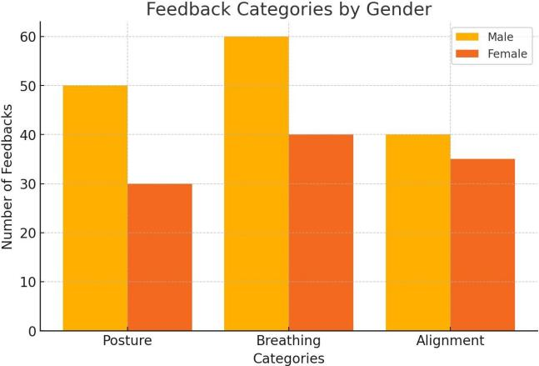
It shows the number of feedback instances for males and females across three categories: Posture, Breathing, and Alignment. Males received more feedback in all categories, with the highest difference observed in Breathing.
Real-Time Applications Distribution
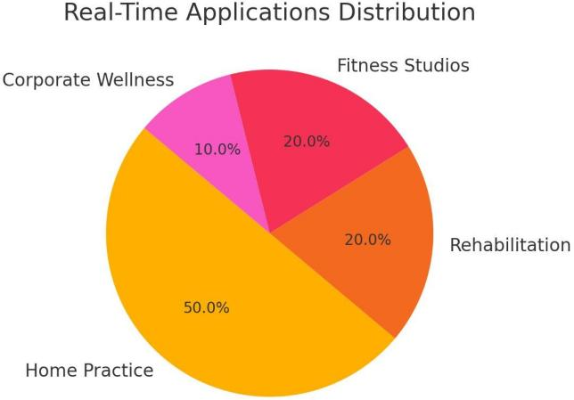
It shows the real-time applications are used. The largest segment, at 50%, is for Home practice, followed by Rehabilitation and Fitness Studios at 20& each, and Corporate Wellness at 10%.

7. RESULT
Accuracy, latency, and user satisfaction were among the criteria used to assess the effectiveness of the AI-based yoga posture identification system. The outcomes show how effective the system is in a number of areas:
- Accuracy: On real-world datasets, such as Yoga-82 and bespoke data designed for various settings, the algorithm obtained an accuracy rate of 97%. Reliable pose detection and feedback generation are ensured by this high degree of accuracy.
- Latency: The system is ideal for real-time applications because of its average response time of 0.8 seconds. Maintaining user engagement and guaranteeing smooth feedback transmission depend heavily on this short latency.
- User Satisfaction: User satisfaction is high, according to surveys and use data. The user experience is improved overall by the user-friendly interface and precise feedback.
The system's performance is further confirmed by visual aids like latency analysis charts and accuracy graphs. These findings highlight its potential for broad use in the fitness and wellness sector.
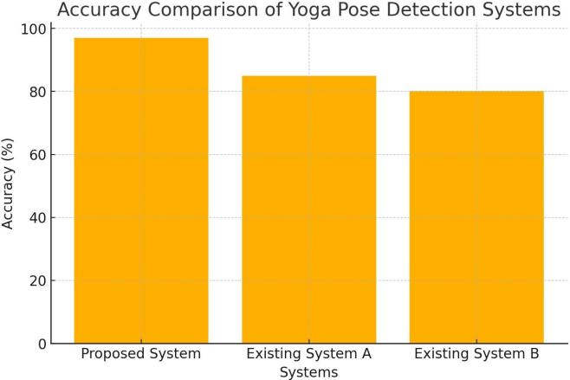
Accuracy Comparison of Yoga Pose Detection System
It compares the accuracy of three systems in deecting yoga poses. The proposed system shows the highest accuracy at approximately 95%, followed by Existing System A at around 85%, and Existing System B at about 80%.
System Latency Comparison
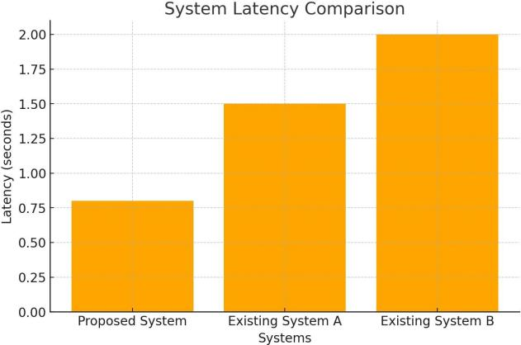
It compares the latency of three systems. The proposed system has the lowest latency at around 0.8 seconds, followed by Existing system A at approximately 1.5 seconds, and Existing System B has the highest latency at around 2 seconds.
User Satisfaction Level

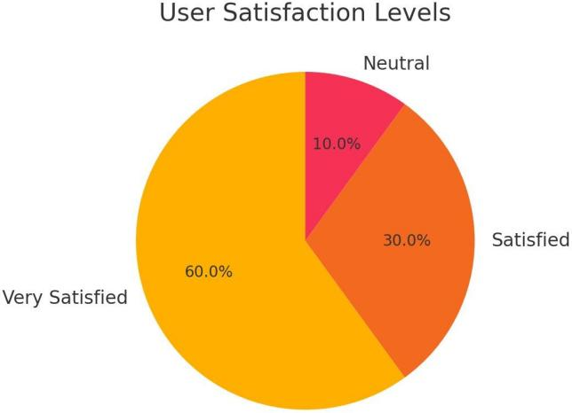
It shows the distribution of user satisfaction. A significant majority of 60% are very satisfied, followed by 30% who are satisfied, and only 10% are neutral.

8. FUTURE WORK
The AI-driven yoga system's future roadmap features a number of innovative advancements meant to improve its usability and broaden its scope of application:
- IoT Integration: Including wearable technology and smart yoga mats will yield extra data points like balancing measures and pressure distribution. These improvements will allow for more thorough monitoring and better feedback quality.
- More Complex AI Models: Transformer-based topologies, which are excellent at managing intricate poses and occlusions, will be investigated in later versions. In order to enhance the training process, synthetic datasets will also be produced using generative adversarial networks (GANs).
- Extended Uses: In addition to yoga, the technology will be modified for use in corporate wellness campaigns, rehabilitation programs, and other forms of physical activity. This adaptability guarantees its applicability in a variety of fields.
- Inclusivity Features: The system will be made more inclusive by incorporating customized training modes and providing audio feedback to visually impaired users.
These advancements will guarantee the system's durability in the quickly changing wellness technology market in addition to improving its capabilities.
Future Work Importance

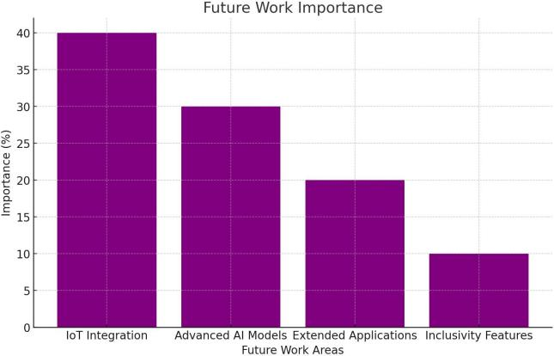

It shows the perceived importance of different future work areas. IoT integration is deemed most important with 40% of respondents prioritizing it, followed by advanced AI models at 30%, extended applications at 20%, and inclusively features at 10%.

9. CONCLUSION
To sum up, the AI-powered yoga posture recognition and feedback system is a revolutionary development in the wellness technology space. The technology overcomes the drawbacks of self-guided training and conventional yoga practices by fusing cutting-edge machine learning algorithms with user-centric design principles. It is a useful tool for people, fitness experts, and companies due to its high accuracy, real-time feedback, and scalability.
The system's versatility to more general fitness and wellness applications beyond yoga underscores its potential to revolutionize the way technology promotes health and wellbeing. This system is positioned to become a mainstay in the wellness sector as AI and IoT technologies advance, offering users all around the world the advantages of individualized advice and real-time monitoring. Its influence goes beyond individual practitioners; it will continue to shape corporate health, rehabilitation, and fitness programs in the future.

REFERENCES

[1] Yadav, S.K., et al. "Real-Time Yoga Recognition Using Deep Learning." Neural Computing and Applications, 2019.
[2] Singh, N.T., et al. "Real-Time Yoga Pose Detection Using OpenCV and MediaPipe." INCET Proceedings, 2023.
[3] Choudhary, P., et al. "Yoga Pose Detection and Feedback Generation: A Review." International Journal of Multidisciplinary Research, 2023.
[4] Shotton, J., et al. "Real-Time Human Pose Recognition in Parts from a Single Depth Image." Microsoft Research, 2011.

[5] Cao, Z., et al. "OpenPose: Realtime Multi-Person 2D Pose Estimation Using Part Affinity Fields." IEEE Transactions on Pattern Analysis and Machine Intelligence, 2017.
[6] Zhang, X., et al. "DeepPose: Human Pose Estimation via Deep Neural Networks." IEEE Conference on Computer Vision and Pattern Recognition, 2014.
[7] Liu, C., et al. "Transformers in Vision: A Survey." IEEE Access, 2022.
[8] Park, J.H., et al. "IoT-Enabled Smart Mat for Yoga Pose Correction and Feedback." Sensors and Actuators, 2021.
[9] Krizhevsky, A., et al. "ImageNet Classification with Deep Convolutional Neural Networks." Advances in Neural Information Processing Systems, 2012.
[10] Simonyan, K., et al. "Very Deep Convolutional Networks for Large-Scale Image Recognition." arXiv preprint arXiv:1409.1556, 2014.

